Haustoria Description
‘ ‘Daikon game’ Haustoria Respiration Apparatus (Haustorium in Skotoperiod)

a kind of simple silly/cute 'horror' game, only scary in the sense that the artist will not willingly draw anything cute in a happy setting.

Necessary:
Pygame
Vscode (python)
(maybe more so we can load my sprites)
(arjun, this is your part to make things compile and work together in the files)

Zak read here and below
|
|
V

a simple little game where the main mechanics are:
- grabbing and throwing objects to progress and or fight (weapons)
- getting water & light (chlorophyll) (which deplete over time)
- gaining 'effects' which allow the player to fight
- simple combat (like hollow knight)
- movement tech **
- saving (like hollow knight benches)

Gameplay wise the player (daikon) has to navigate through generally dark regions and over time has to find water and light to survive while fighting enemies. If the light or water is fully depleted, then the player has to find an enemy (which later becomes the main survival tactic) to take water and light from or they die via psychosis.

Composed of 3 main parts:
Part one: overworld/garden, easiest level, rarely requires Haustoria, and enemies are very easy to kill, day-night cycle is short, and there are plenty of sources of light and water. Easy to no parkour and does not require much skill or movement tech. It is simple and meant as an introduction to the actual game.

Part two: underground/dirt tunnels, medium level, has some difficulty, bosses are introduced, and haustoria begins to become more of a used skill, enemies pose more of a threat and the day night cycle is substantially elongated (if not permanently night in some regions). Parkour is made more difficult, but is still doable with basic movement tech.

Part three: flesh tunnels, difficult level, bosses now do almost all the players HP haustoria is the only way to get chlorophyll and water, day night cycle is perma-night. Parkour requires advanced movement tech and hints are introduced when saving.

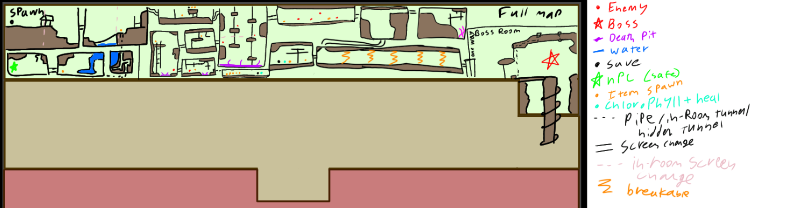
Map WIP

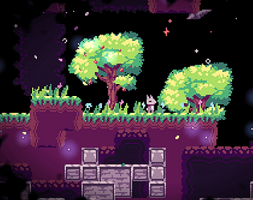
Level 1:
surface/gardens
https://onlinesequencer.net/5378725 (day theme)
(Night theme)
(Threat theme)

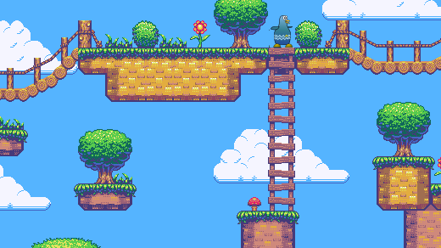
overworld/garden, easiest level, rarely requires Haustoria, and enemies are very easy to kill, day-night cycle is short, and there are plenty of sources of light and water. Easy to no parkour and does not require much skill or movement tech. It is simple and meant as an introduction to the actual game.

Bosses:

- Dragonfly (region 3)

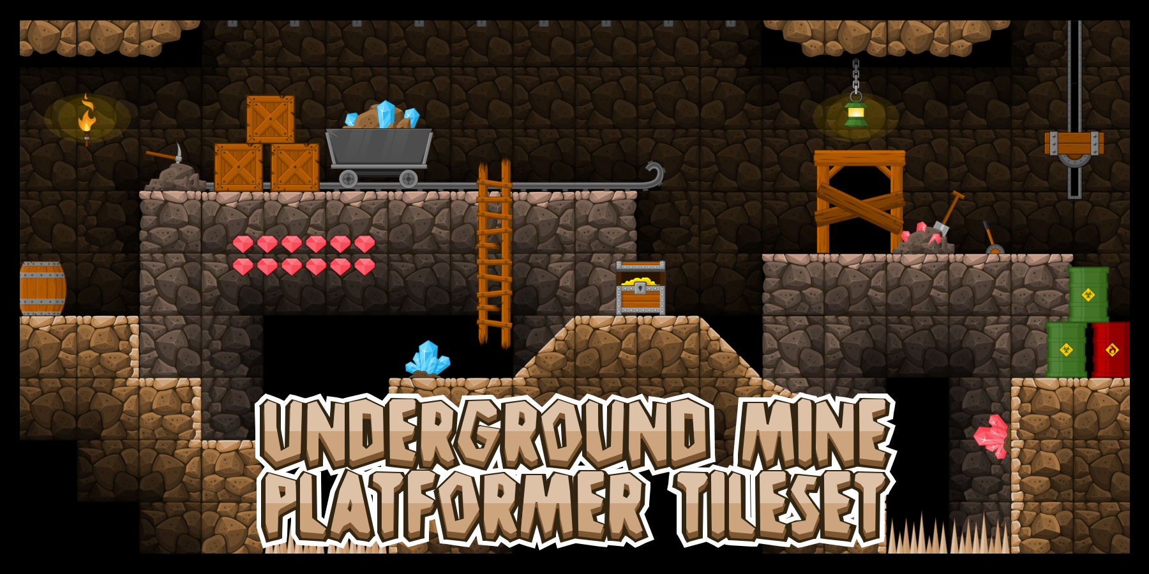
Level 2:
Under ground
Day theme (https://onlinesequencer.net/5401314)

underground/dirt tunnels, medium level, has some difficulty, bosses are introduced, and haustoria begins to become more of a used
skill, enemies pose more of a threat and the day night cycle is substantially elongated (if not permanently night in some regions). Parkour is made more difficult, but is still doable with basic movement tech.

Bosses:

Burrowyrm (region 1)
Aphids (a ton of aphids) (region 2)
(2) Wasp(s) (region 3)


Level 3:
Flesh tunnels
https://onlinesequencer.net/5381801 (Theme)

flesh tunnels, difficult level, bosses now do almost all the players HP haustoria is the only way to get chlorophyll and water, day night cycle is perma-night. Parkour requires advanced movement tech and hints are introduced when saving.

Bosses:
Flesh-Maggot (region 1)
Bell beast (region 2)
Rhino Beetle (region 3)


Real image WIP
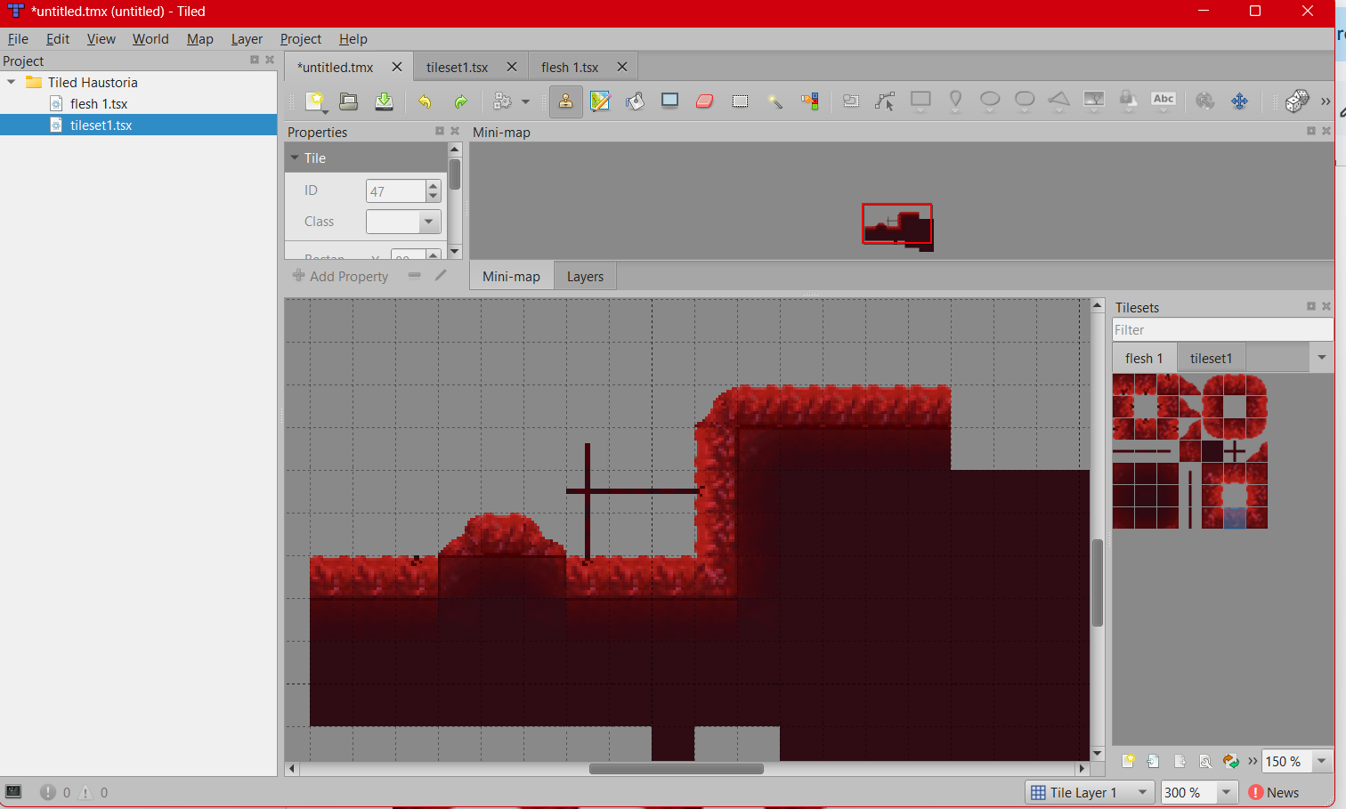

Tileset flesh1.png
Don't mind the quality

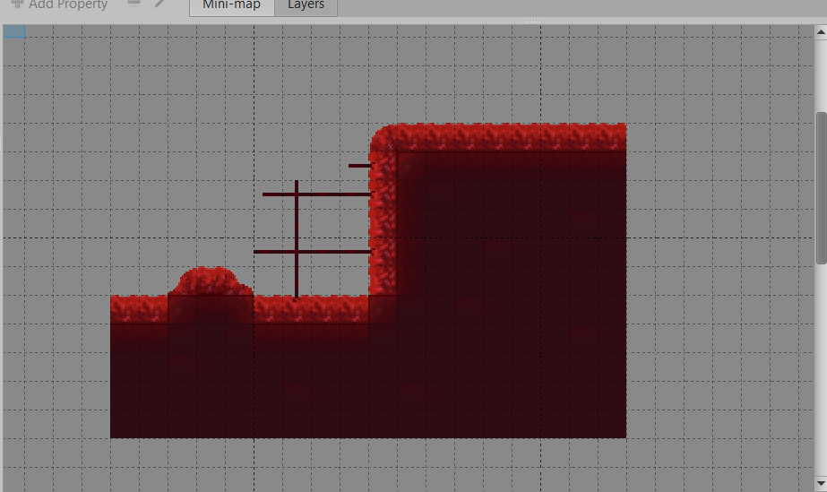

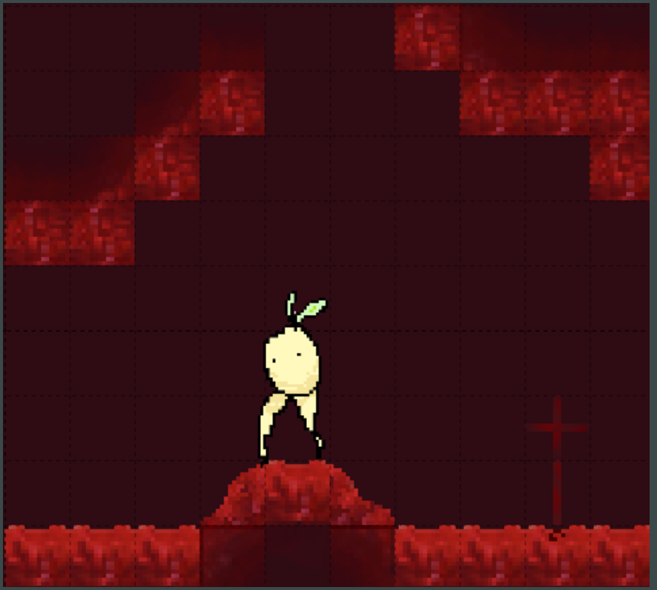

SPRITES ^V^ made by Ame

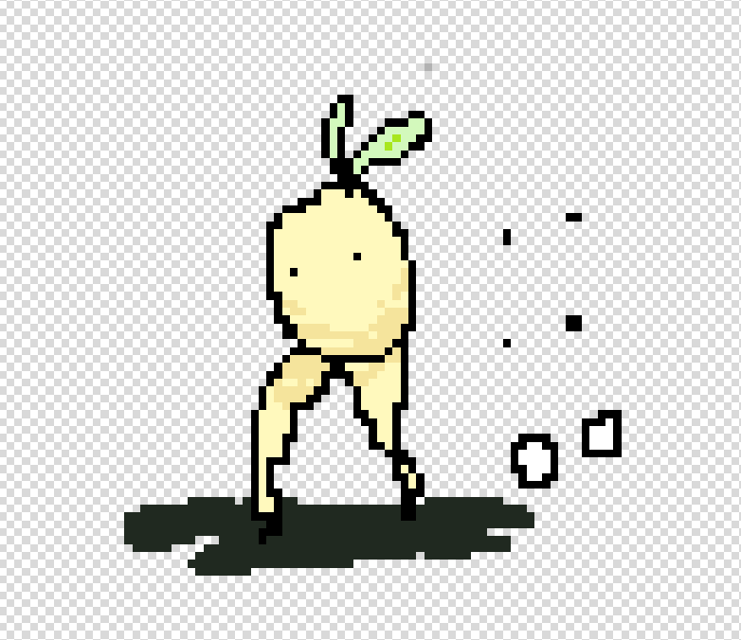
MC/player standing still



Player using haustoria (no shadow) (inverse of the vessel from HK lmao)


second boss (a daikon burrowing worm, but very big) 3 times bigger than player
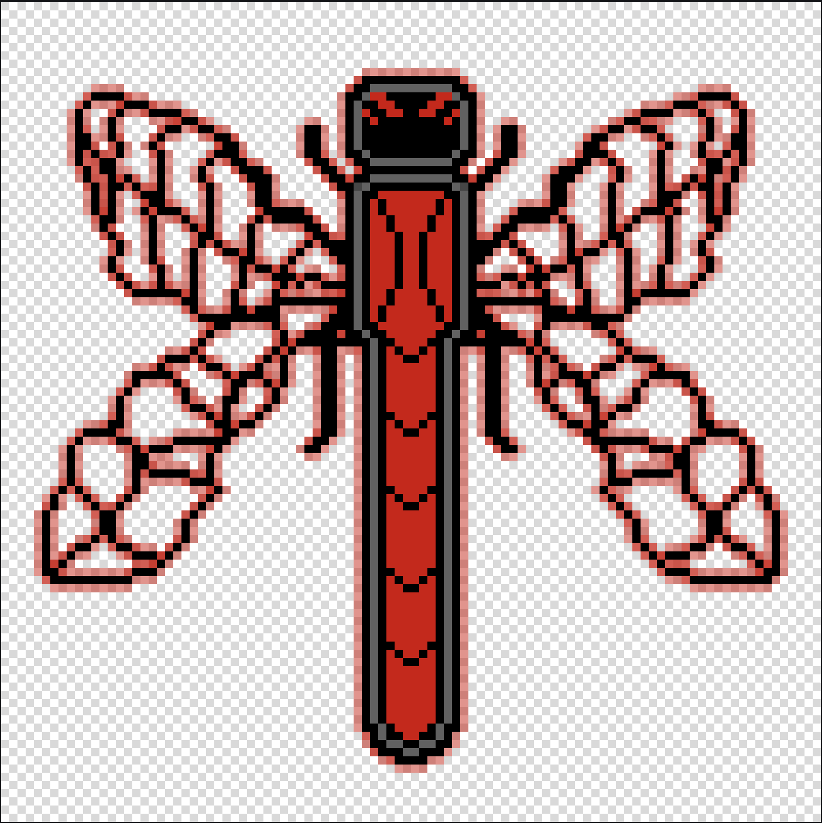level 1 Dragonfly 2 times bigger than the burrowing worm

boss in level 2 Aphids

Gameplay Mechanics
Gameplay Mechanics:
- Haustoria ability – an ability where the player attacks a NPC and plays a simple animation while sticking to the NPC and taking Chlorophyll and Water

- Objects on each level are available to pick up. The player must use some of these objects to progress by using them directly or to throw them as weapons to fight or use as platforms for movement on vertical surfaces.
- Water & Chlorophyll are the health of the player. They deplete over time. Chlorophyll is more scarce but completely replanishes health.
- The player gains effects from some plants which allow him to move faster or jump higher or do more damage than normal. Effects change the color or outline of the character to indicate they are active and last a limited amount of time.
- Simple combat (like hollow knight)
- Using spears for close combat, or throwing spears for range combat.
- Attacks can be parried if the player attacks while an enemy’s attack is at the edge of the player's hitbox (by a small range so it's not pixel perfect).
- Rocks can also be thrown to stun.

- Movement:
- Wall-clinging and slowly slide down (like hollow knight)
- Spear-bounce (Like hollow knight)
- Wall climbing (side to side jumping when wall clinging to close enough walls)
- Rolling (when falling from more than jump height. Keybinds would be downward movement (gravity) + ‘D/A’ or ‘left/right’)
- Dash
- Sliding (‘A/D’ + ‘S’ in succession or ‘left/right’ + ‘down’ in succession)
- Jumping
- Moving normally (ASWD / Arrow Keys)
- Additional things like hitting walls causing small knockback allows for more movement tech like slide-wall-pounces

- saving (like hollow knight benches)

Gameplay wise the player (daikon) has to navigate through generally dark regions and over time has to find water and light to survive while fighting enemies. If the light or water is fully depleted, then the player has to find an enemy (which later becomes the main survival tactic) to take water and light from or they die via psychosis (effect).

Region day-night cycle depends on level, level 1 has day night cycle every 10 min for a full cycle of 6 min of day and 4 of night.
Level 2 has day-night in region 1 and 2, but not in 3. Day night lasts for 10 min, 3 min of day 7 of night.
Level 3 has no day night cycle. Instead, has a timer for every 5 min until more enemies spawn through ‘night’ spawns, but there is never a day time, just less spaws in the ‘day’.

